

Mohd. Razia Alangir Banu
D.VENKAT SAI

2520090034
CSIT
CO1 – Foundations & Sorting Algorithms

Case Study Topic: Meesho – Product Inventory & Search Management System (CO1 Focus: BST & AVL Trees)
Work Done Summary:
Meesho is an online shopping platform that manages thousands of product records daily. In this system, Binary Search Trees (BST) and AVL Trees are used to efficiently store and manage product information such as Product ID, product name, price, and stock quantity. BST is used for performing operations like insertion, searching, and deletion of products, while AVL Trees maintain balance in the data structure to avoid performance degradation. Rotations such as LL, RR, LR, and RL are applied whenever imbalance occurs. This ensures faster product lookup, inventory updates, and smooth management of large-scale e-commerce data with O(log n) complexity.

Implementation Details:
1. Product information like Product ID, name, category, price, and stock is stored using BST nodes.
2. BST is used for insertion, searching, and deletion of products in the inventory.
3. Products are organized hierarchically based on Product ID for efficient retrieval.
4. AVL Tree is implemented to maintain a balanced structure during frequent updates.
5. Balance factors are checked after every insertion or deletion and rotations are applied when required.
6. The final structure ensures efficient product management with O(log n) time complexity.
Output:

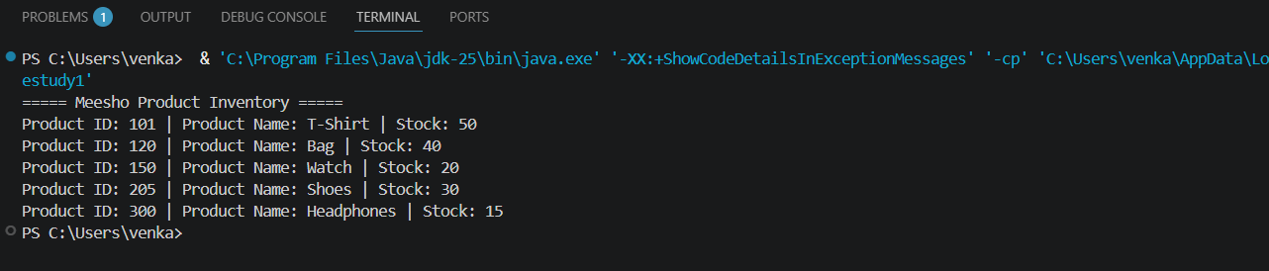

The Meesho inventory management system efficiently handles large product datasets using BST and AVL
Tree structures. BST enables fast searching and updating of product records, while AVL Tree maintains balance
to ensure consistent performance. This improves inventory management, scalability, and response time in real-
time e-commerce operations.

Github link: https://github.com/Venkat-267-byte/DSA-II

